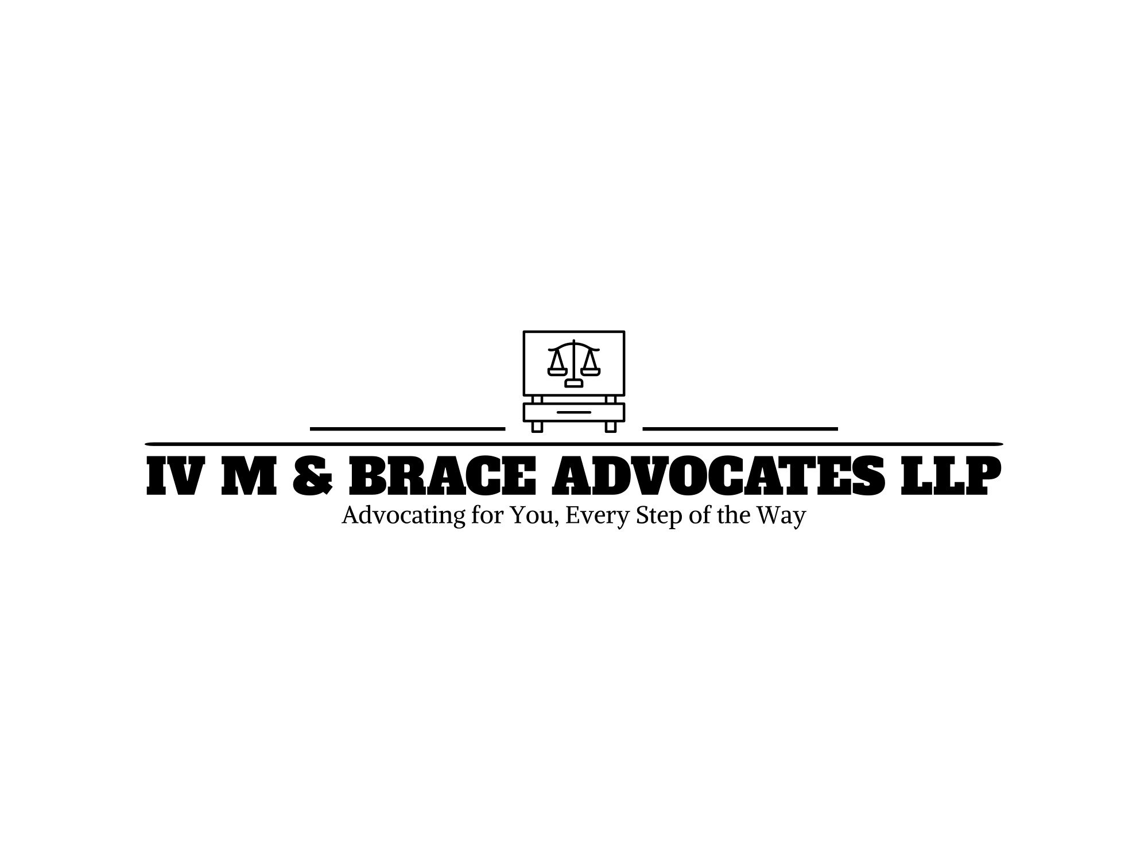
SEXUAL HARASSMENT POLICY
MARCH 2024



CLASS C, FIRM 10

MEMBERS;

NO | FIRM MEMBERS | REG. NUMBER
1. | OGOTI CYNTHIA MWANGO | 20240523
2. | WAITHAKA RICHARD GATITU | 20240494
3. | ABDULBASIT AHMED ADAN | 20240290
4. | ESTHER WANGARI MAINA | 20240495
5. | CHIWAYA NYAMAWI JULIUS | 20240499
6. | WINNIE KAGWIRIA MUTHUURI | 20241753
7. | BRIAN FELIX ODERO | 20240749
8. | ZITAH MWENDE NKONGE | 20240493
9. | KUMUTAI EMMANUEL | 20241263

SEXUAL HARASSMENT POLICY
IV M & BRACE Advocates LLP is committed to providing a work environment that is free from sexual harassment and any form of discrimination. We value the dignity, diversity and rights of all our employees, clients and stakeholders. We recognize that sexual harassment is a serious and unacceptable violation of these values and we will not tolerate any such conduct in our firm. Consequently, we have established this sexual harassment policy which shall be effective from 2/03/2024.

Objective
The purpose of this policy is to:
- Define sexual harassment and provide examples of unacceptable conduct.
- Establish a reporting procedure for employees who experience or witness sexual harassment.
- Outline the investigation procedure and the disciplinary action for sexual harassment complaints.
- Ensure confidentiality and protection from retaliation for complainants and witnesses.
- Promote training and awareness on sexual harassment prevention and response.

Scope
This policy applies to all employees, partners, associates, consultants, contractors, clients, and visitors of IV M & BRACE Advocates LLP, regardless of their position, rank, or status. This policy covers sexual harassment that occurs in the workplace, during work-related activities, or in any other situation where the conduct affects the work environment.

Definition of Sexual Harassment
Sexual harassment is any unwelcome conduct of a sexual nature that makes a person feel offended, humiliated or intimidated, and that a reasonable person would anticipate that reaction in the circumstances. Sexual harassment may include, but is not limited to:
- Sexual advances, requests or demands for sexual favors, either explicitly or implicitly, as a condition of employment, promotion, training, or other benefits;
- Unwanted physical contact such as touching, hugging, kissing, patting, pinching, or brushing against another person’s body;
- Verbal or written comments, jokes, innuendoes, propositions, or insults of a sexual nature, or based on a person’s sex, gender identity, sexual orientation, or marital status;
- Displaying, sending, or requesting sexually explicit or suggestive images, messages, or materials, such as posters, cartoons, calendars, emails, texts, or videos;
- Making or using derogatory or stereotypical remarks, gestures, or noises of a sexual nature, or based on a person’s sex, gender identity, sexual orientation, or marital status;
- Spreading rumors or making false allegations about a person’s sexual behavior or activities;
- Creating or contributing to a hostile, intimidating, or offensive work environment based on a person’s sex, gender identity, sexual orientation, or marital status.
Sexual harassment may occur between persons of the same or different sex, and may involve a single incident or a series of incidents. Sexual harassment may also occur outside the workplace or normal working hours, such as during work-related trips, social events, or online communications, if there is a connection to the employment relationship.

Reporting Procedure
Any employee who experiences or witnesses sexual harassment is encouraged to report it as soon as possible to any of the following persons:
- Their immediate supervisor or manager.
- The Human Resources Manager.
- The Managing Partner.
- Any member of the Gender Committee.
The report may be made verbally or in writing, and should include the following information:
- The name and position of the complainant and the respondent.
- The date, time, place, and description of the incident(s) of sexual harassment.
- The names and contact details of any witnesses or evidence of the incident(s).
- The action or remedy sought by the complainant.
The person who receives the report shall acknowledge it and inform the complainant of their rights and responsibilities under this policy. The person who receives the report shall also notify the Human Resources Manager and the Managing Partner of the report, unless they are the respondent or a witness.
Any employee who makes a complaint of sexual harassment in good faith will not be disadvantaged or prejudiced in any way. However, any employee who makes a false or malicious accusation of sexual harassment will be subject to disciplinary action, up to and including termination of employment. The firm will also take appropriate action against any person who attempts to interfere with or obstruct the investigation or resolution of a complaint.

Investigation Procedure
Upon receiving a report of sexual harassment, the Human Resources Manager and the Managing Partner shall appoint a Special Panel to conduct an investigation. The Special Panel shall consist of three members, who shall be impartial, qualified, and trained in handling sexual harassment cases. The Special Panel shall include at least one member of the Gender Committee and at least one member of the opposite sex of the complainant and the respondent.
The Special Panel shall conduct the investigation in a prompt, fair, and confidential manner, following the principles of natural justice and due process. The investigation shall include the following steps:
- Interviewing the complainant, the respondent, and any witnesses or relevant persons.
- Reviewing any documents, records, or materials related to the case.
- Making findings of fact and determining whether sexual harassment has occurred or not.
- Preparing a written report of the investigation, with recommendations for appropriate action.
The investigation shall be completed within 30 days of receiving the report, unless there are exceptional circumstances that require an extension. The Special Panel shall submit the report to the Human Resources Manager and the Managing Partner, who shall communicate the outcome of the investigation to the complainant and the respondent.

Support and Protection Measures
IV M & BRACE Associates will provide support and protection to any employee who reports or experiences sexual harassment in the workplace. This may include, but is not limited to:
- Offering counseling, medical or legal assistance, or referrals to external services
- Adjusting the work arrangements, such as changing the work schedule, location or duties, of the complainant or the alleged harasser, if requested and feasible
- Ensuring that the complainant and the alleged harasser do not have to work together or interact during the investigation, if possible and appropriate
- Taking interim measures to prevent further harassment or retaliation, such as issuing a warning, suspension or transfer, to the alleged harasser, if necessary and justified
- Protecting the complainant and any witnesses from any adverse consequences, such as victimization, discrimination or reprisal, for reporting or participating in the investigation

Disciplinary Action
If the investigation finds that sexual harassment has occurred, the Human Resources Manager and the Managing Partner shall take appropriate disciplinary action against the respondent, in consultation with the Special Panel and the Gender Committee. The disciplinary action shall be proportional to the severity and frequency of the sexual harassment, and may include any of the following:
- A verbal or written warning or reprimand.
- A suspension or termination of employment.
- A demotion or transfer to another position or department.
- A reduction or withholding of salary or benefits.
- A referral to counseling or training.
- A referral to legal action or prosecution.
The disciplinary action shall be implemented within 14 days of communicating the outcome of the investigation, unless there are exceptional circumstances that require a delay. The disciplinary action shall be documented and recorded in the respondent’s personnel file.

Confidentiality
All parties involved in a sexual harassment case, including the complainant, the respondent, the witnesses, the Special Panel, the Human Resources Manager, the Managing Partner, and the Gender Committee, shall maintain confidentiality and respect the privacy of the information and the persons concerned. Any unauthorized disclosure or misuse of information related to a sexual harassment case may result in disciplinary action or legal liability.

Appeals
The parties will have the right to appeal the decision or the actions, if they are dissatisfied with the outcome, within 14 days of receiving the written communication. The appeal should be made in writing to the Managing Partner, or the authorized person, stating the grounds and the desired outcome. The Managing Partner, or the authorized person, will review the appeal and make a final decision, which will be communicated to the parties in writing within 14 days of receiving the appeal.
The Human Resources Manager, or the designated person, will keep a record of the complaint, the investigation, the outcome, and any actions taken, and will monitor the situation to ensure that the complaint is resolved satisfactorily and that there is no recurrence or retaliation. The record will be kept confidential and secure, and will only be accessed or disclosed as necessary for the purposes of the process or as required by law.

Protection from Retaliation
No employee shall be subjected to any form of retaliation, victimization, or discrimination for making a report of sexual harassment, participating in an investigation, or supporting a complainant or a respondent. Any employee who engages in or condones any such retaliation shall be subject to disciplinary action, up to and including termination of employment.
Any employee who believes that they have been retaliated against for their involvement in a sexual harassment case shall report it to the Human Resources Manager, the Managing Partner, or the Gender Committee, who shall investigate the matter and take appropriate action.

Prevention and Education
IV M & BRACE Associates shall provide regular and mandatory training and awareness programs on sexual harassment prevention and response for all employees, partners, associates, consultants, contractors, clients, and visitors. The training and awareness programs shall cover the following topics:
- The definition and examples of sexual harassment.
- The rights and responsibilities of employees under this policy and the law.
- The reporting and investigation procedure for sexual harassment complaints.
- The disciplinary action and remedies for sexual harassment cases.
- The effects and impacts of sexual harassment on individuals and the firm.
- The strategies and skills for preventing and responding to sexual harassment.
The training and awareness programs shall be conducted by qualified and experienced trainers, in collaboration with the Human Resources Manager and the Gender Committee. The training and awareness programs shall be evaluated and reviewed periodically to ensure their effectiveness and relevance.

Review and Monitoring
This policy shall be reviewed and updated annually to reflect the changes in the law, the best practices, and the feedback from the employees and the stakeholders. The Human Resources Manager and the Gender Committee shall be responsible for monitoring the implementation and compliance of this policy, and for reporting the progress and challenges to the Managing Partner and the Board of Directors. The Human Resources Manager and the Gender Committee shall also maintain records and statistics of sexual harassment cases and their outcomes, and shall use them for analysis and improvement purposes.

